11.52:1 audio output transformer
P/N: | 2477A4
Winding ratio: | 11.52:1
Primary impedance: | 140KΩ
Secondary impedance: | 1KΩ
Primary DC impedance: | 2.916KΩ
Secondary DC impedance: | 64.4Ω
Primary inductance @ 300HZ 0.25V: | 1.059H
Secondary inductance @ 300HZ 0.25V: | 8.96H
Primary inductance @ secondary short circuit: | 468.2H
Secondary-secondary capacitance (20KHz): | 93.46pF

Schematic

⑤
⑧
①
④

⑥
⑦
③
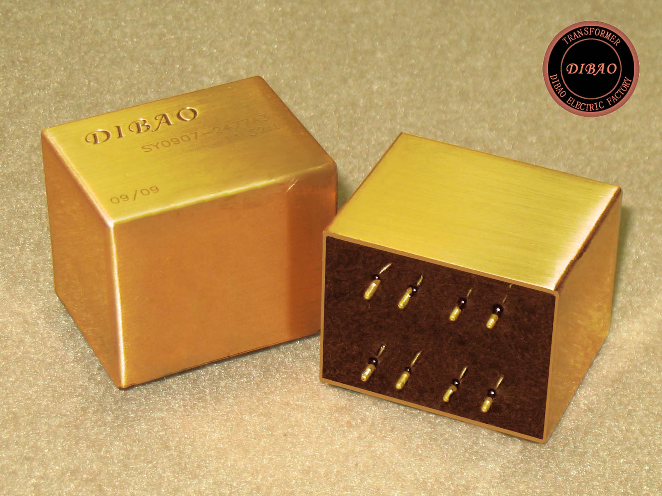
Dimension  (mm) | H | 30
Dimension  (mm) | L | 36
Dimension  (mm) | W | 28
Weight  (Kg) | ≈
H
L
www.dibao.com
W
①
②
③
④④
⑤
⑥
⑦
⑧⑧
15.24
17.78
5.08
7.62

