
Chinese English Home Page News Product Feedback About US WebMap
Product Directory
Power Transformer
Audio Transformer
Three Phase Transformer
Auto Transformer
Control Transformer
Power Adapter
Special Transformer

More Information About Toroidal Lighting Transformer

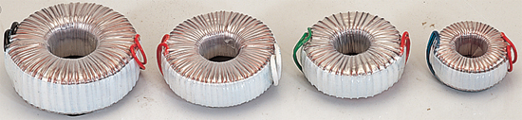
Toroidal Lilghting Transformer Specifications:
*Toroidal power transformer designed for haloid lighting;
*Small cubage, low temperature raise.

Sizes Of Form And Installations:
Model | Capacity  (VA) | Input  (V) | Frequency  (HZ) | Output  (V) | Temperature  raise  (℃) | Formal Size |  | Weight  kg | Fix-OS  (mm) | screw  (mm)
 |  |  |  |  |  | H (mm) | D (mm) | Weight  kg | Fix-OS  (mm) | screw  (mm)
LB-30 | 30 | 220V | 50 | 12 | ≤65 | 32 | 74 | 0.6 | Φ6.5 | M6
LB-50 | 50 | 220V | 50 | 12 | ≤65 | 33 | 83 | 0.75 | Φ6.5 | M6
LB-80 | 80 | 220V | 50 | 12 | ≤65 | 37 | 100 | 1.1 | Φ6.5 | M6
LB-105 | 105 | 220V | 50 | 12 | ≤65 | 37 | 111 | 1.4 | Φ8.5 | M8
LB-120 | 120 | 220V | 50 | 12 | ≤65 | 44 | 106 | 1.6 | Φ8.5 | M8
LB-150 | 150 | 220V | 50 | 12 | ≤65 | 43 | 116 | 1.85 | Φ8.5 | M8
LB-190 | 190 | 220V | 50 | 12 | ≤65 | 48 | 121 | 2.3 | Φ8.5 | M8
LB-240 | 240 | 220V | 50 | 12 | ≤65 | 50 | 125 | 2.6 | Φ8.5 | M8
LB-300 | 300 | 220V | 50 | 12 | ≤65 | 54 | 128 | 3 | Φ8.5 | M8
LB-500 | 500 | 220V | 50 | 12 | ≤65 | 60 | 135 | 5.3 | Φ8.5 | M8

The Picture Of Installation

The Picture Of Formal Size

Detailed Product Description

